2021 AIPG MN Annual Meeting – December 15, 2021
Attending the meeting: Shanna Schmitt, Dan Hunter, Alex Blel, Marian Kramer, Rebecca Ryser, Patrick Sweeney, Ben Czeck, Paul Putzier, Lauren Larkin, Jeffery Neisse, Keith Rapp, Paula Berger, Bruce Johnson (left early), Kelton Barr, Curt Hudak, Jake Dalbec, Miller Gruenewald, Christina Morrison
The Meeting was called to order at 3:10 PM.
- Review and approve 2020 Annual Meeting Minutes
  - Jake Dalbec made a motion to amend the 2020 annual meeting draft minutes to include Jake Dalbec and Shanna Schmitt’s Annual reports for 2020 Executive Committee positions; motion passed.

- Election results:
  - 34 voting AIPG-MN members.
  - Summary of results
    - President-Elect – Ben Czeck, MEM-2877
      - Received 100% of votes.
    - Vice President – Marian Kramer, MEM-2463
      - Received 97% of votes.

- Office and Committee Reports – See attached unless noted
  - President
    - AIPG-MN was successful at adapting to virtual meetings and technical talks in 2021.
  - President-Elect
    - Ongoing interviews with BIPOC folks within the industry.
    - Sending out a poll for dates, time, and frequency of ExComm meetings in 2022.
    - Will require volunteers for coordination with AIPG-WI for a joint field trip.
  - Vice President
    - Technical talk attendance was still strong despite COVID challenges and virtual talks.
    - Will send Marian Kramer a spreadsheet of previous technical talks to see what has been done in the past.
  - Secretary
    - In 2021, his field schedule kept him from many meetings. In 2022, should be able to attend more meetings with different role at Braun.
  - Treasurer
    - Golf outing was greatest expense in 2021, but it also generated almost $2,800 in revenue.
    - Gave out six FG exam grants and a $1,000 scholarship in 2021.
  - Past President – No report
  - Fundraising Chair
    - Golf scramble attendance declined due to last-minute decision to host event.
    - $2,797.97 of net income in 2021.
    - PayPal fees were over 4% of annual income.
    - Need to push for more golfer participation and door prizes/auction items in 2022.
    - Possibly looking for a new golf course (other than Prestwick) to host the golf outing in 2022.
    - Marian suggested more marketing of the golf event in 2022. Expand to more members and get new members included.
  - Membership Chair
    - 185 members total in 2021 with 25 new members in 2021.
    - Approximately 88% of new members in 2021 were students or early career professionals.
    - 9 corporate sponsors in 2021. Up from 8 in 2020 and down from 10 in 2019. $250/sponsor.
    - Paula mentioned starting the conversation of resuming in-person meetings and offering a virtual option.
  - Education Chair
    - The pandemic and virtual learning led to less grant applications getting sent out or received.
    - We may need to change up how grant letters are sent out. Maybe not include a faculty sponsor.
  - Regulation & Legislative Chair
    - Not a lot happening with legislation in 2021.
    - ASBOG committee met in-person in 2021.
    - FG and PG exams with be done on computers in 2023. Still only offering two testing dates from 2023 on.
    - Testing can be done at multiple locations instead of traveling to St. Paul to sit for the FG or PG exam.
    - Task Analysis Surveys (TAS) are important to be taken by past test-takers to ensure test material is pertinent for each state. Shanna proposed AIPG-MN promote members to take TAS.
    - ASBOG Professional Geologist position will be open in 2023. APIG-MN could recommend a geologist for the open board position.
  - Newsletter Chair – No report
  - Webmaster
    - In 2021, most website updates were small changes.
    - Continued to send out email blasts, announcements, job postings, technical talks, etc.
    - Switched from PayPal to StarChapter pay in 2021.
  - Nomination Chair – No report, Appointment Pending
  - Screening Chair – No report, Appointment Pending
  - State Mapping Advisory Committee
    - State Mapping Advisory Committee Annual Meeting held October 28, 2021.
    - The committee will have six projects to focus on and receive funding for in the coming year.

- Mineral Kit Donation for the Minnesota Minerals Education Workshop (MMEW).
  - No kits donated in 2021. The mineral kits were not distributed due to the cancellation of the MMEW meeting until in-person workshops can resume safely, hopefully in 2022.
  - Mike Hultgren has approximately 20 kits set aside for donation.
  - Possible MMEW June 2022 workshop
  - MMEW might donate mineral kits to earth science teachers across the state.
  - Christina made a motion to set aside up to $1,2000 for donation of mineral kits to earth science teachers at a conference in February 2022. Motion passed.

- TPG Student Issues Order.
  - TPG issues were discontinued in 2021, the reason was the limited in-person school. The link to the TPG was provided in lieu of hard copies.
  - A limited number of hard copies may be order once in-person events continue.

- Donation to host Chapter for annual meeting.
  - $250 was made to the Annual meeting in 2021.
  - ExComm will address 2022 donation at later date.

- New Appointments for 2022.
  - Director #1 will be filled by Dan Hunter as Past President. Term 2022.
  - Director #2, currently held by Alex Blel. Term of 2021-2022.
  - Director #3, currently held by Paul Putzier, will be open in 2022.
  - Director #4, currently held by Lauren Larkin. Term of 2021-2022.
  - Director #5, currently held by Kelsi Ustipak, will be open in 2022.
  - Director #6, currently held by Jeff Neisse. Term of 2021-2022.
  - State Mapping Advisory Committee, AIPG Member. Held by Jake Dalbec.
  - Webmaster &Assistant Webmaster. Shanna Schmitt and Jake Dalbec agreed to continue.
  - Education Chair. Currently held by Mike Hultgren.

- Sponsorship
  - Routinely consists of a group of 8-9 sponsors.
  - Paula has sent out a letter requesting to current Sponsors to continue their Sponsorship.

- Other Items of Discussion
  - Need to add two additional Microsoft Company licenses (Which includes Microsoft Teams):
    - A Motion was made by Shanna Schmitt to add two licenses to Microsoft 365 account with Microsoft Teams included; Motion passed.
    - APIG-MN will add two more licenses in order to help run technical talks if Shanna is unavailable.

  - A resolution to start a Committee on Racial Awareness in our Section: Dan Hunter will Head
    - Dan Hunter will plan to move ahead with the Committee in the coming year.
    - The committee was an exploratory committee in 2021, now named “Committee on Racial Awareness”.
    - Mention an article regarding racism in the intro to the December Technical Talk.

  - State Mapping Committee Update
    - Addressed by Jake Dalbec in his officer update. He has documents that will be linked on the AIPG-MN website.
  - New Committee Officer Transitions
    - Past officers have or will meet with new officers to help the transition process.

Shanna Schmitt made a motion to adjourn the meeting; motion carried. Meeting adjourned at 5:03 PM.

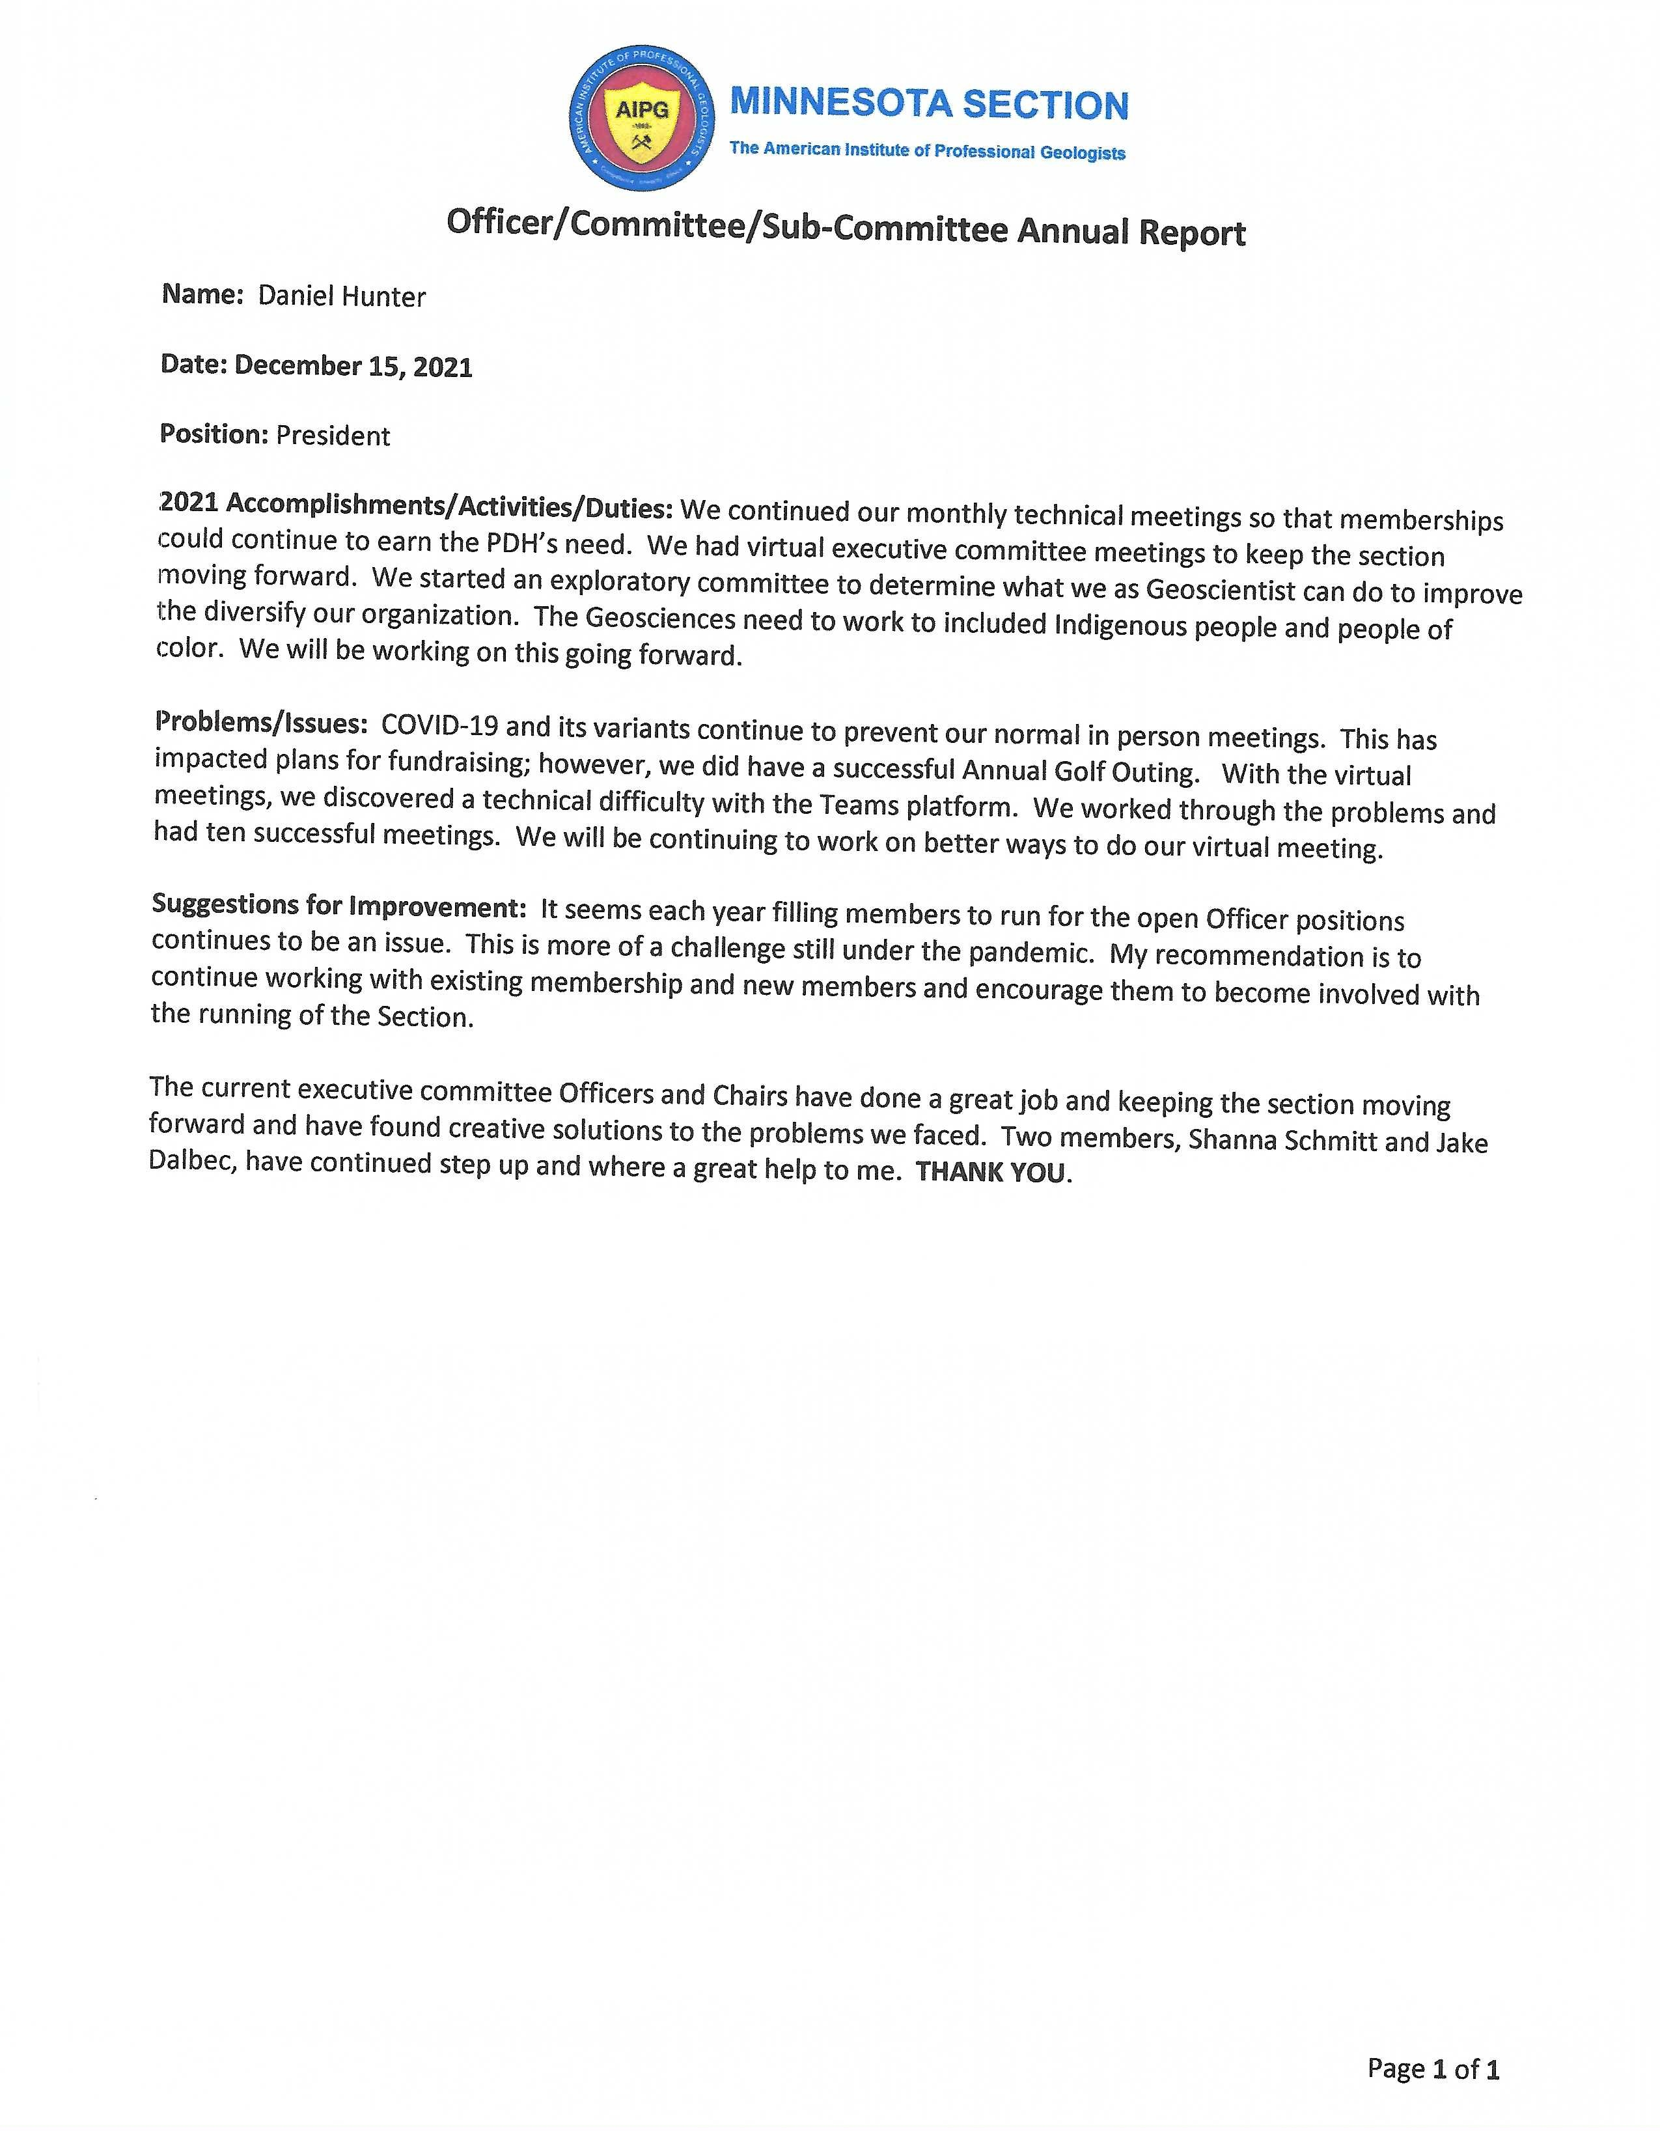

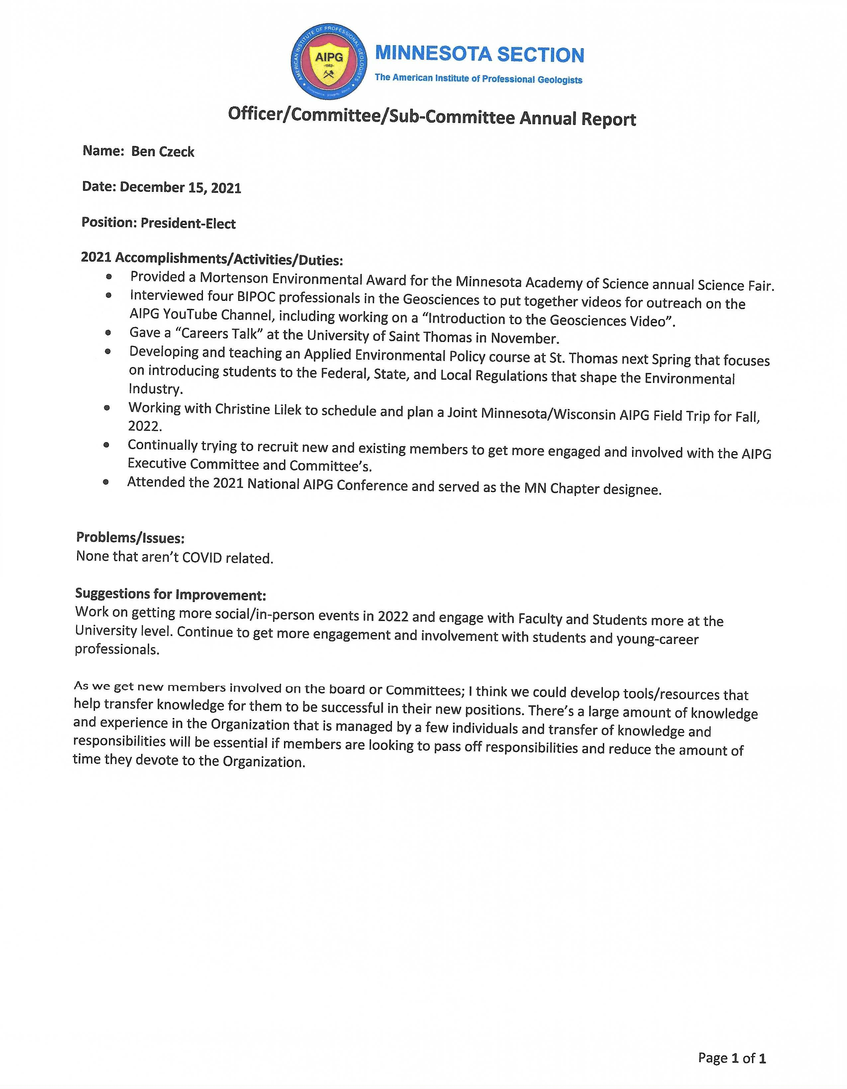

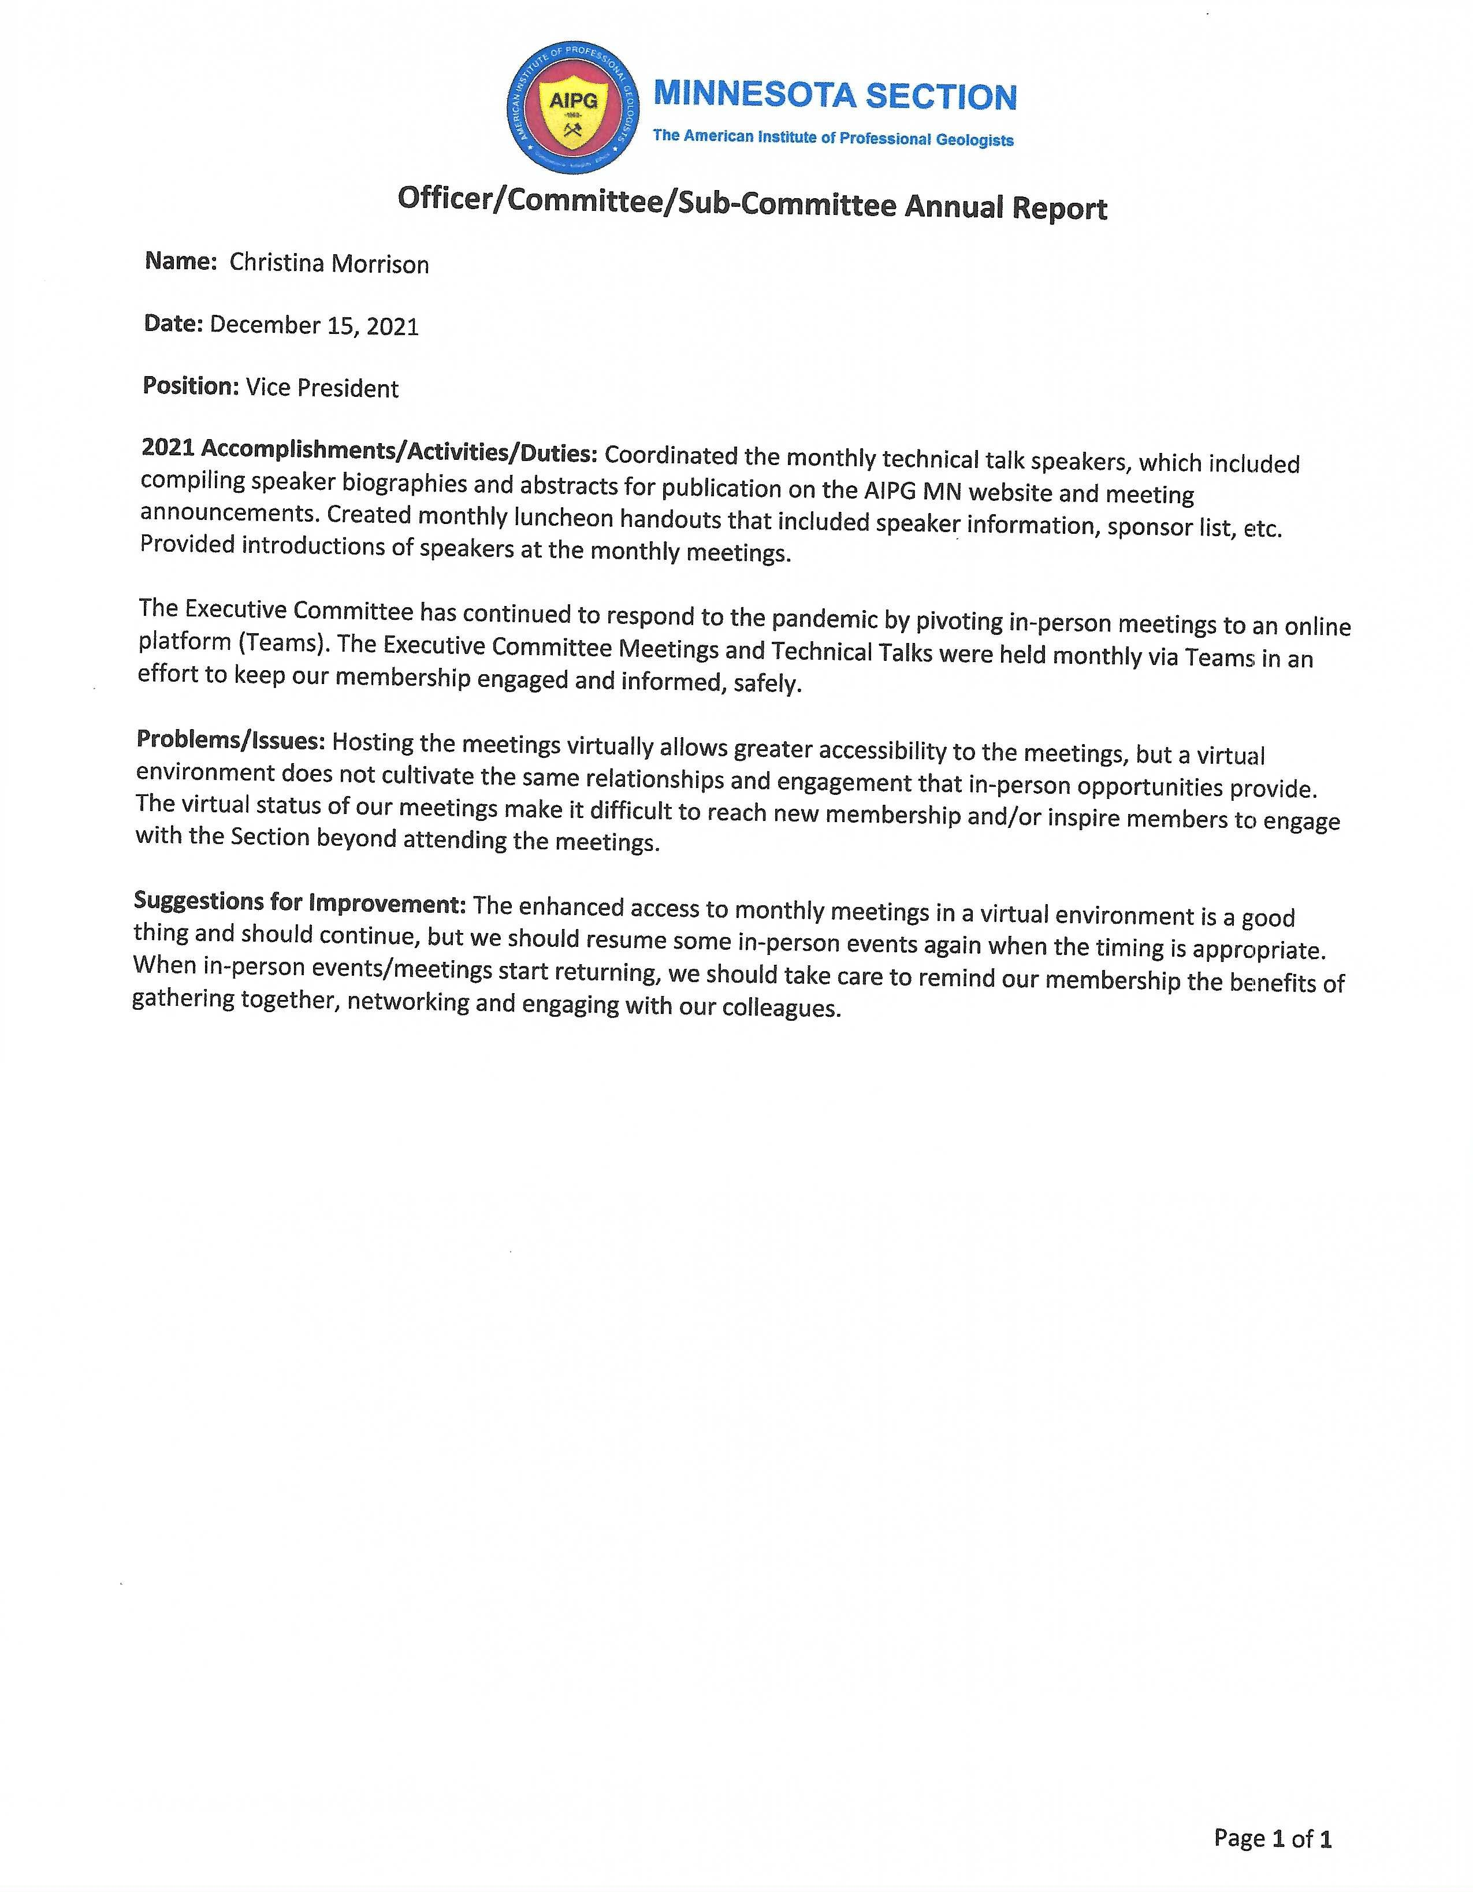

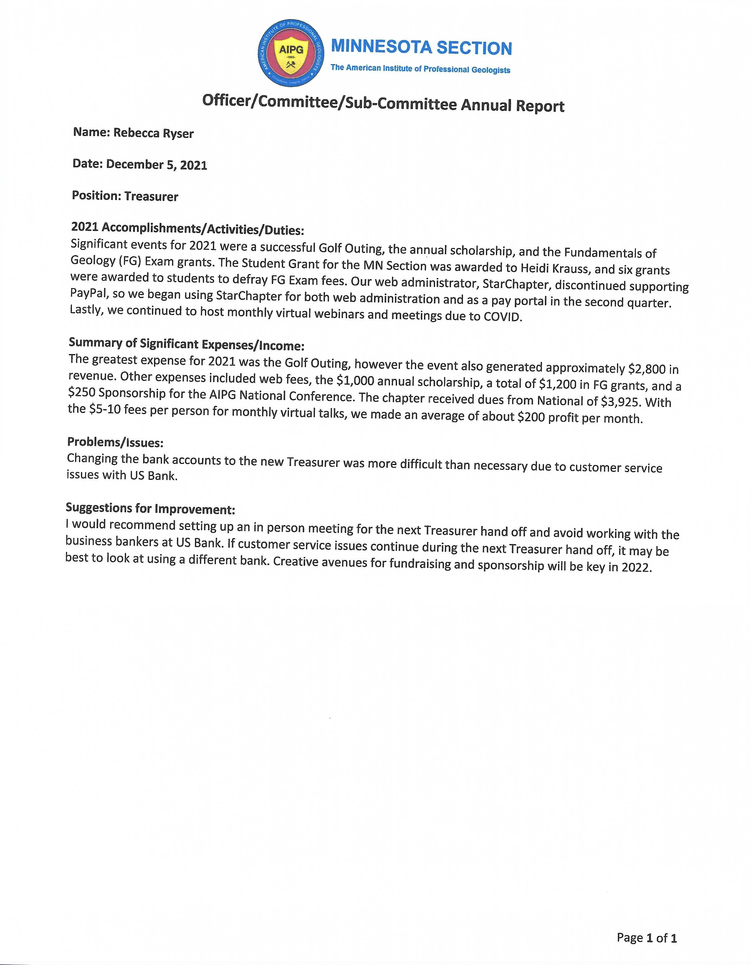

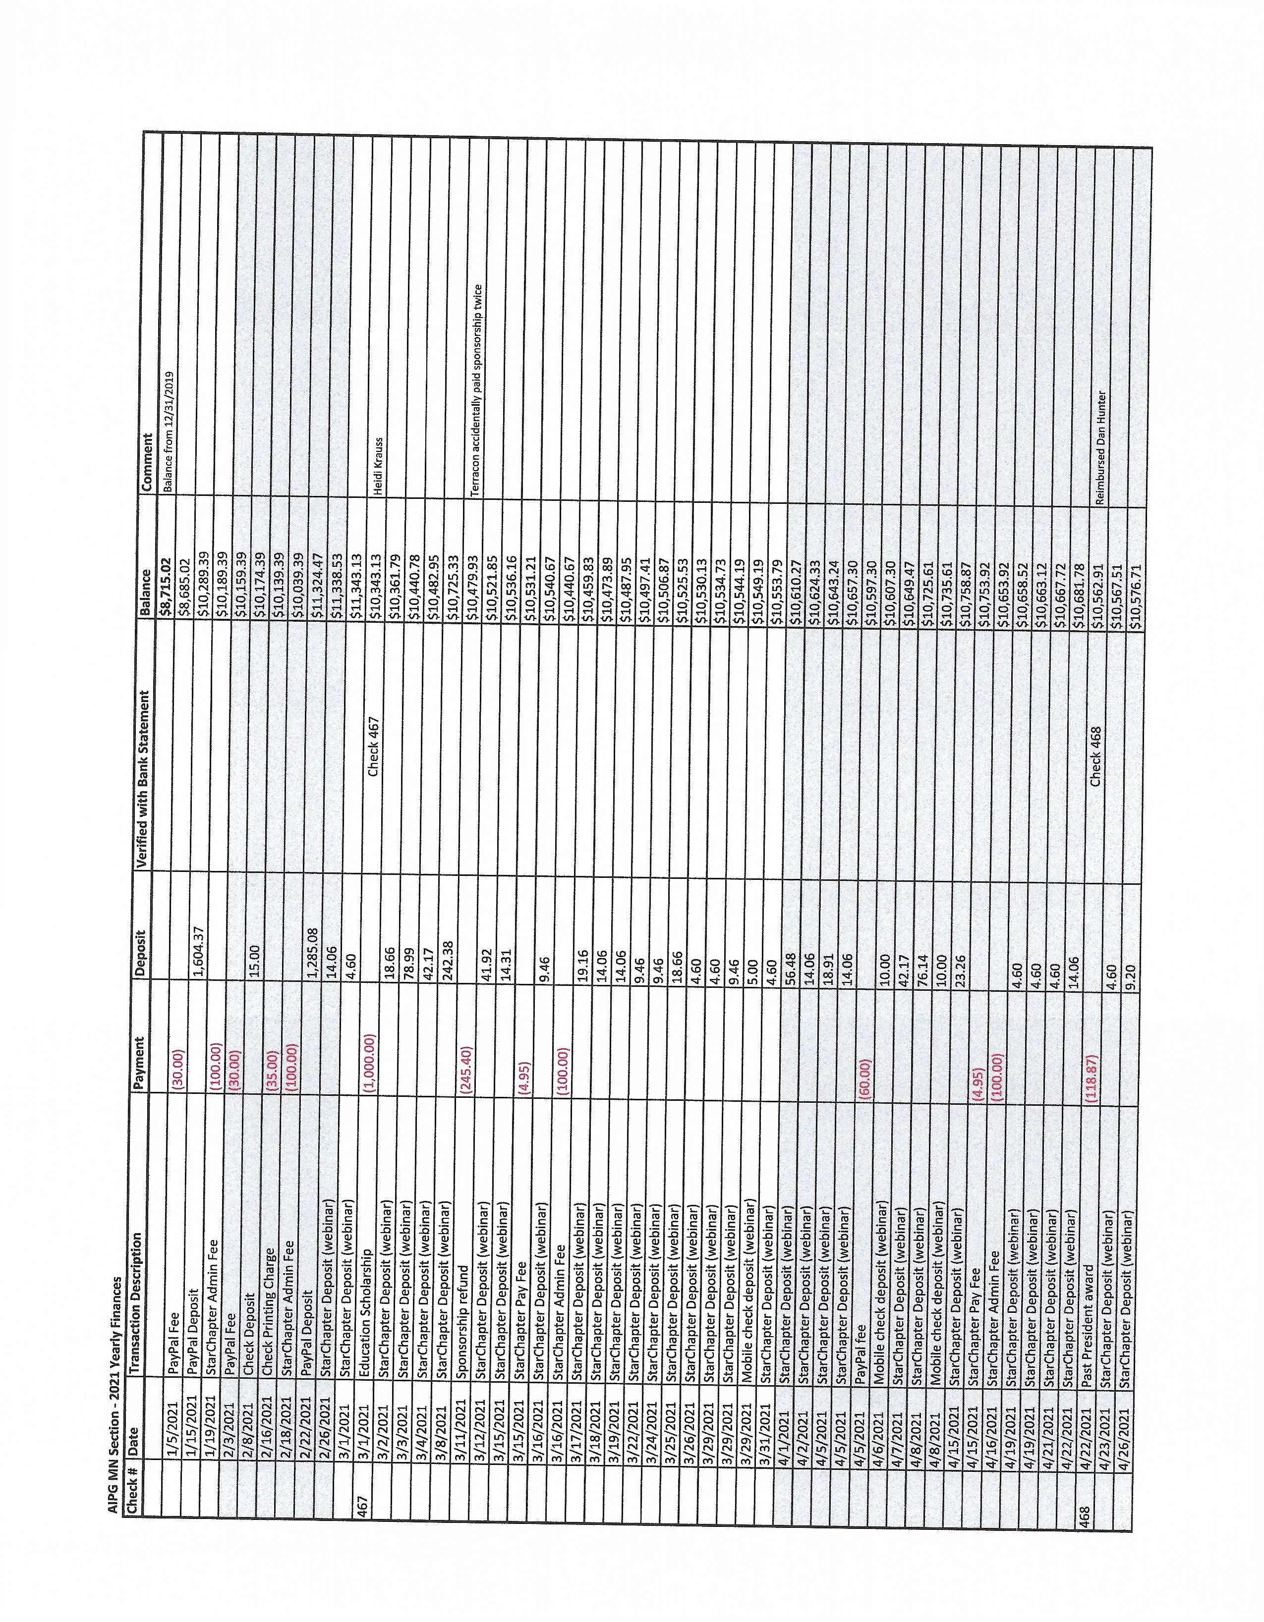
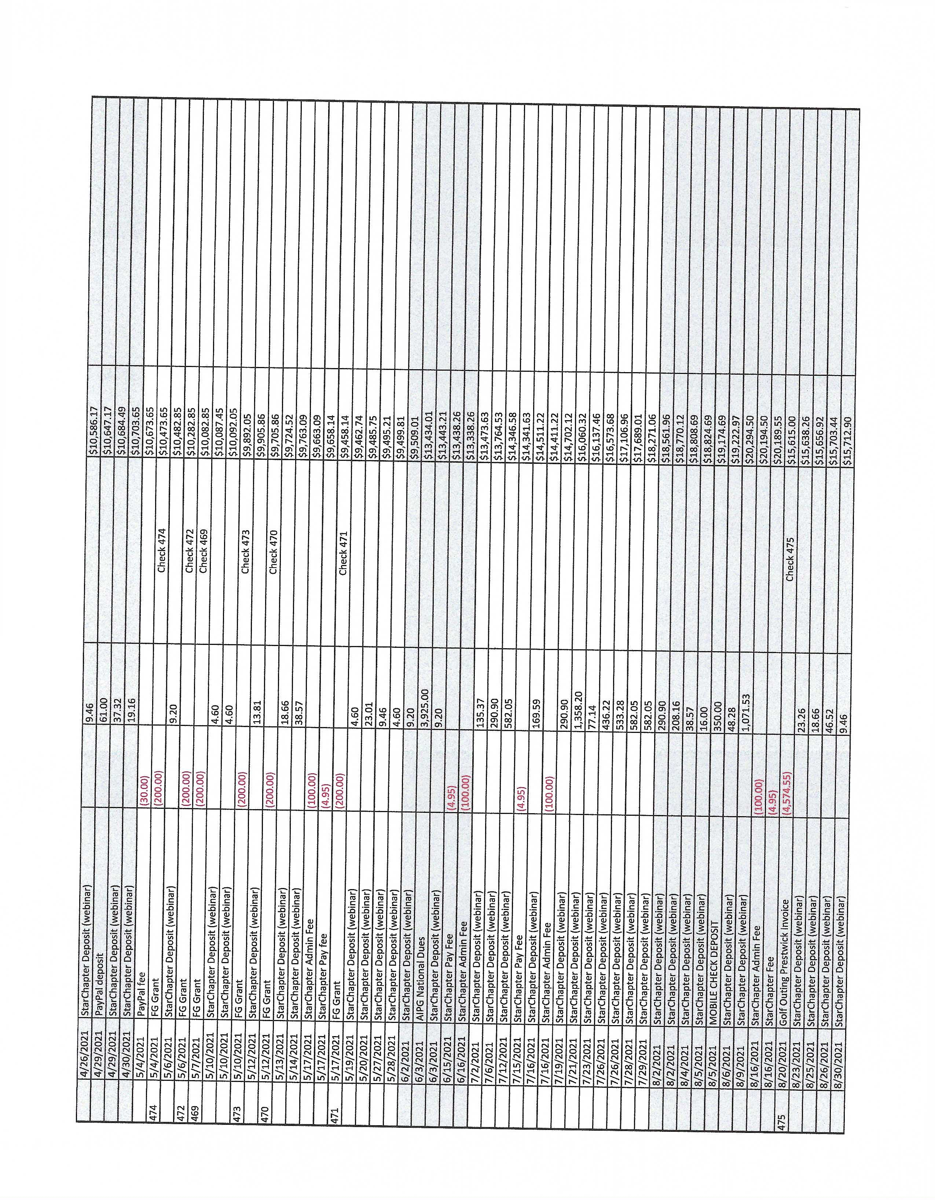

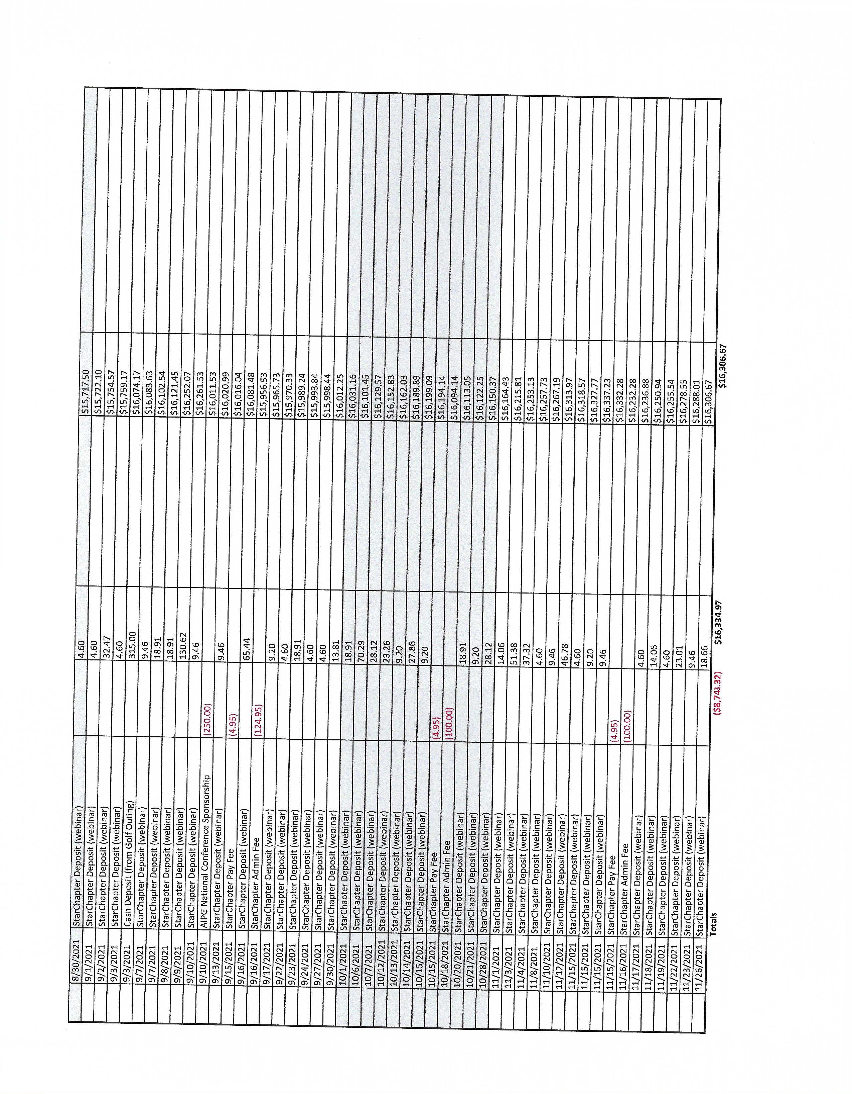

Officer/Committee Annual Report
Name: Fundraising Annual Report
Date: December 15, 2021
Position: Fundraiser Chair
2021 Accomplishments/Activities/Duties: The AIPG Minnesota Section held its 2021 annual golf fundraiser on August 5th at Prestwick Golf Course in Woodbury, MN. Thirty-nine golfers (39) attended this year, which is down from 58 golfers in 2019 (the 2020 golf fundraiser was canceled because of Covid-19 pandemic). We had witnessed a steady upward trend in the number of golfers each year since 2014 (see Table 1 below) until this year’s downturn. We believe that this downturn was primarily caused by either the late decision to proceed with the 2021 golf fundraiser, which impacted the ability for our contributing companies and agencies to participate, or that our contributors were playing catch-up at their jobs because of Covid-19 project delays, or both reasons combined. In addition to our 2021 golf participants, 7 non-golfers attended the auction/dinner after the golf event at The Wick Pub & Grill, which is down from 12 non-golfers in 2019. Overall, the dinner/auction event went down to 46 total participants from 70 in 2019. This year’s non-golfer attendance was similar to the 2014-2017 trends that ranged from 5 to 8 non-golfers, but down from 2018 (14) and 2017 (12). Four of the 7 non-golfers were auction item winners, 1 was a donor, indicating that the non-golfer attendees remain fairly active participants. The 46 total people was our second lowest attendee numbers since we reinitiated the golf fundraiser in 2014, when 2014 witnessed our lowest participation at 43 total people. Total diners decreased from 70 in 2019 to 46 in 2021.

Table 1
Year | 2021 | 2020 | 2019 | 2018 | 2017 | 2016 | 2015 | 2014
Golfers | 39 | N/A | 58 | 48 | 46 | 44 | 42 | 38
Non-Golfers | 7 |  | 12 | 14 | 7 | 5 | 8 | 5
Total Diners | 46 |  | 70 | 62 | 53 | 49 | 50 | 43

The 2021 golf fundraiser broke a spiking trend in volunteer time and effort that brought in auction items and specifically more higher priced live auction items. We only had one auction item worthy of a live auction, the other lesser auction items were all part of our silent auction. The largest auction income amount was $225 for a foursome of golf at Prestwick Golf Course donated by our hosts at Prestwick (live auction) and was the only auction item that sold for more than $100.

Summary of Significant Expenses/Income
Table 2 below summarizes the net income and expenses. Table 2
Profit Calculation
Income =  Expenses = | $7,586.00
Income =  Expenses = | $4,788.03
Net Income = | $2,797.97

Prestwick Golf Course continues to be an excellent host, is very organized, and has charged us a bargain rate of
$70/golfer ($12.00 more than in 2019) for one of the higher rated golf courses in the Twin Cities area. The Wick
Pub & Grill staff worked with us to customize a new menu to keep the costs at exactly $20.00 per plate, which was was a $1 decline in prices from 2019’s per plate costs, and only a slightly higher cost than the $19.00/plate price in 2018. We once again heard very positive comments from the diners on the selection of food and available beverages. This 2021 year featured a “Down South” Fried Chicken meal compared to the past few years, which were a BBQ Meal in 2019, and Mexican-themed dinners in 2018 and 2017.

Table 3 summarizes the trend of both expenses and net profit for the golf fundraiser.
Table 3
Year | 2021 | 2019 | 2018 | 2017 | 2016*** | 2015 | 2014
Total Income | $7,586.00 | $12,285.00 | $10,111.00 | $8,540.00 | $8,198.00 | $7,890.00 | $6,195.00
Eagle Card Income*** | $700.00 | $1,450.00 | $1,000.00 | $975.00 | $660.00 | $860.00 | $700.00
Silent Auction Income | $594.00 | $1,840.00 | $1,631.00 | $1,195.00 | $1,104.00 | $1,280.00 | $690.00
Live Auction | $225.00 | $1,020.00 | $850.00 | $345.00 | 0 | $200.00 | n/a
Total Expenses | $4,788.03 | $6,603.54 | $5,566.84 | $4,653.29 | $5,181.70 | $3,959.31 | $3,855.79
Golf Course, Cart & Food | $4,574.55 | $6,313.95 | $5,291.83 | $4,431.20 | $4,423.43 | $3,861.56 | $3,586.21
PayPal Fees** | $213.48 | $289.59 | $275.01 | $222.09 | $194.69 | ? | $123.99
Member Reimbursement* |  |  |  |  | $563.58 | $97.75 | $145.59
Net Income (Profit) | $2,797.97 | $5,681.47 | $4,544.16 | $3,886.71 | $3,016.30 | $3,930.69 | $2,339.21
***(increased Eagle Card from $20 to $25 in 2017)
**(rounding errors from PayPal calculations; didn’t keep separate track of our PayPal costs in 2015, which was likely somewhere around $175-185, or roughly 2.0-2.3% of the Total Income)
*(2016 was the last year that AIPG-MN reimbursed our members for their purchasing of auction and supply items)

Note that our bottom line net income decreased by $2,883.50 over the net income of 2019, or almost 50% decline.
The $2,797.97 net income is our Section’s second lowest income event since we reinitiated the golf fundraiser in 2014 ($2,339.21). Prior to the pandemic year of 2020, our net income had been steadily increasing over the three previous years. We lowered the values of the 1st, 5th and 9th place teams’ Prestwick Gift cards from $40 or $160/team in 2019 to $30/card or $120 per team to help out our profits.

Thirteen door prizes were distributed to 13 different Eagle Card holders including one polished septarian nodule valued at approximately $200, and another 19 different golfers won team or hole prizes. This means that 32 of 39 (82%) unique golfers won at least one prize.

Problems/Issues:
The most pressing issue of 2021 was whether we would hold the fundraiser or not because of fluctuating Covid-19 issues. The late “go” declaration undoubtedly hurt our numbers and profits this year.

Non-golfers were offered the Eagle Cards and all of them declined to make the $25 purchase. We may consider offering “Eagle Cards” to the non-golfers at a lower rate since they do not benefit from winning a golf club door prize or being entered into the hole prizes or using the card’s golf course mulligans.

We are seeing a climb in the use of PayPal versus the use of checks (see Table 3 above). Our range of PayPal fees has been somewhere between 2.0% and 2.5% of the Total Income for past fundraisers. This year saw our PayPal costs double to 4.45% of the total income.

Suggestions for Improvement:
We are actively working to secure a 2022 fundraiser date and price with Prestwick as soon as possible. They are not responding as in past years.

Decide if a “door prize” card could be purchased for a different price by the non-golfers ($10-15/card?). The door prizes this year were almost entirely not golf-related. We also need to continue to keep the number of door prizes high, say mre than 15, to keep the interest in these door prize cards.

We need to continue having one of our volunteers write down the names of the live auction winners. That worked better this year and we remedied the lost revenue from a live auction winner that did not come to collect their prize and pay for it.

We need to continue to keep attracting more and better live and silent auction items, and sooner so that we may better advertise them well (several months at least) before the golf event. This might help to garner more proxy bids (we did have one proxy bid this year). More or higher-priced live auction items will be required to help stay the same or improve upon the auction revenue.

Lastly, are there alternative ways to minimize the PayPal fees that we are currently incurring, which peaked this year at 4.45% of our Total Income?

Summary:
We have been attempting to achieve a net income (profit) of approximately $100/golfer since we reinitiated the golf fundraiser in 2014. Our net income on a per golfer basis was $71.74/golfer in 2021 compared to our all-time record of $97.96/golfer in 2019. Previous years’ high tallies were $94.67 per golfer in 2018, and $93.59/golfer in 2015. Other years were well below $80/golfer with 2014 and 2016 both being the lowest at $61.56/golfer. The Eagle Card has been a great success since we are pushing them harder than ever at a slightly increased rate and these dollars drop right to our bottom line. More door prizes are a necessity to keep us selling the Eagle Cards. We need to continue to keep attracting more and better auction items, and sooner in the year so that we may better advertise them well before the golf event. Early advertising helps to increase our numbers of golfers and non-golfers, which in turn might help to garner more and higher bids.



Officer/Committee Annual Report
Name: Paula Berger
Date: December 15, 2021
Position: Membership Committee Chair
2021 Accomplishments/Activities/Duties:
- Continued sponsorship program with annual sponsorships.
- Solicited 9 corporate sponsors for the 2021 calendar year (up from 8 in 2020 and down from 10 in 2019).
- Three sponsors solicited to date for 2022.
- 185 members total in 2021 with 25 new members in 2021. o Approximately 29% of total members are students or early career professionals.
o 88% of new members in 2021 were students or early career professionals.

Summary of Significant Expenses/Income
- No expenses.
- Income of $250/sponsor. No change in sponsor amount

Problems/Issues:
- Corporate sponsorship was remains relatively constant – fluctuating up and down by one or two sponsors for the past several years.
- Remains to be seen whether the number of sponsorships will change as virtual meetings continue. Sponsors have less visibility.

Suggestions for Improvement:
- None

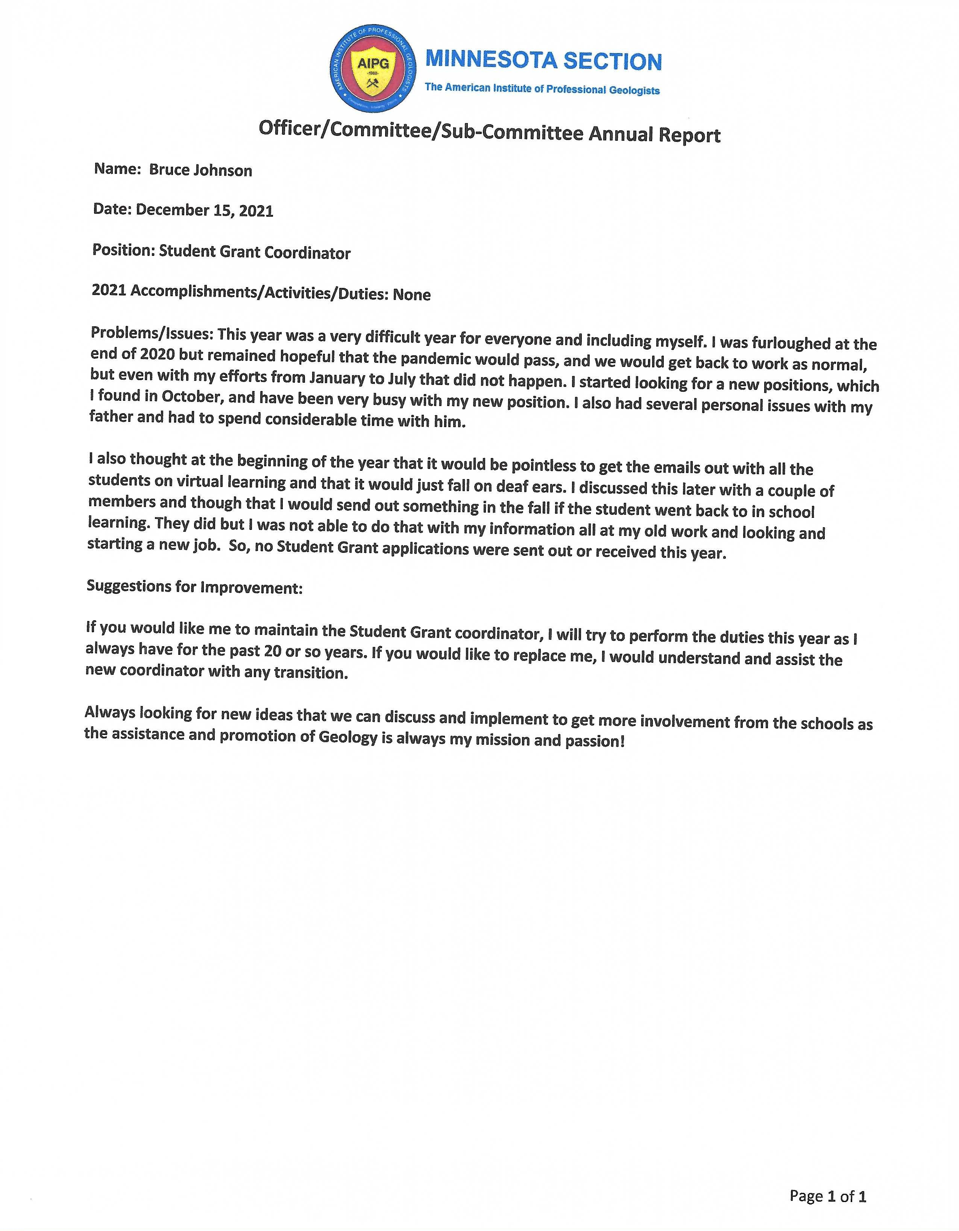
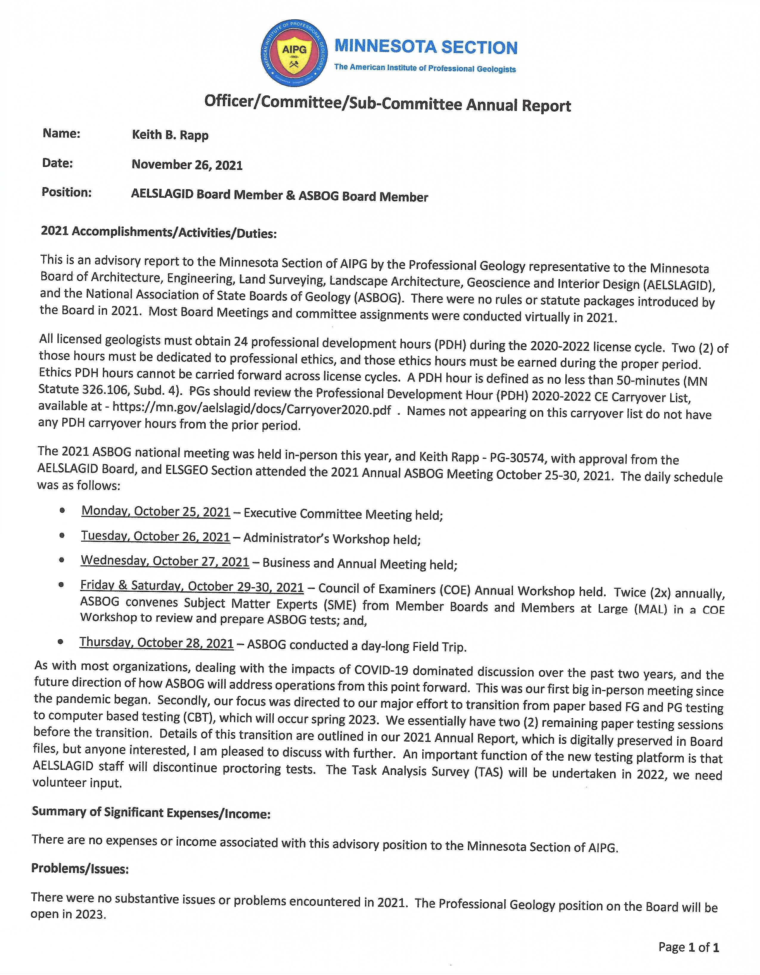
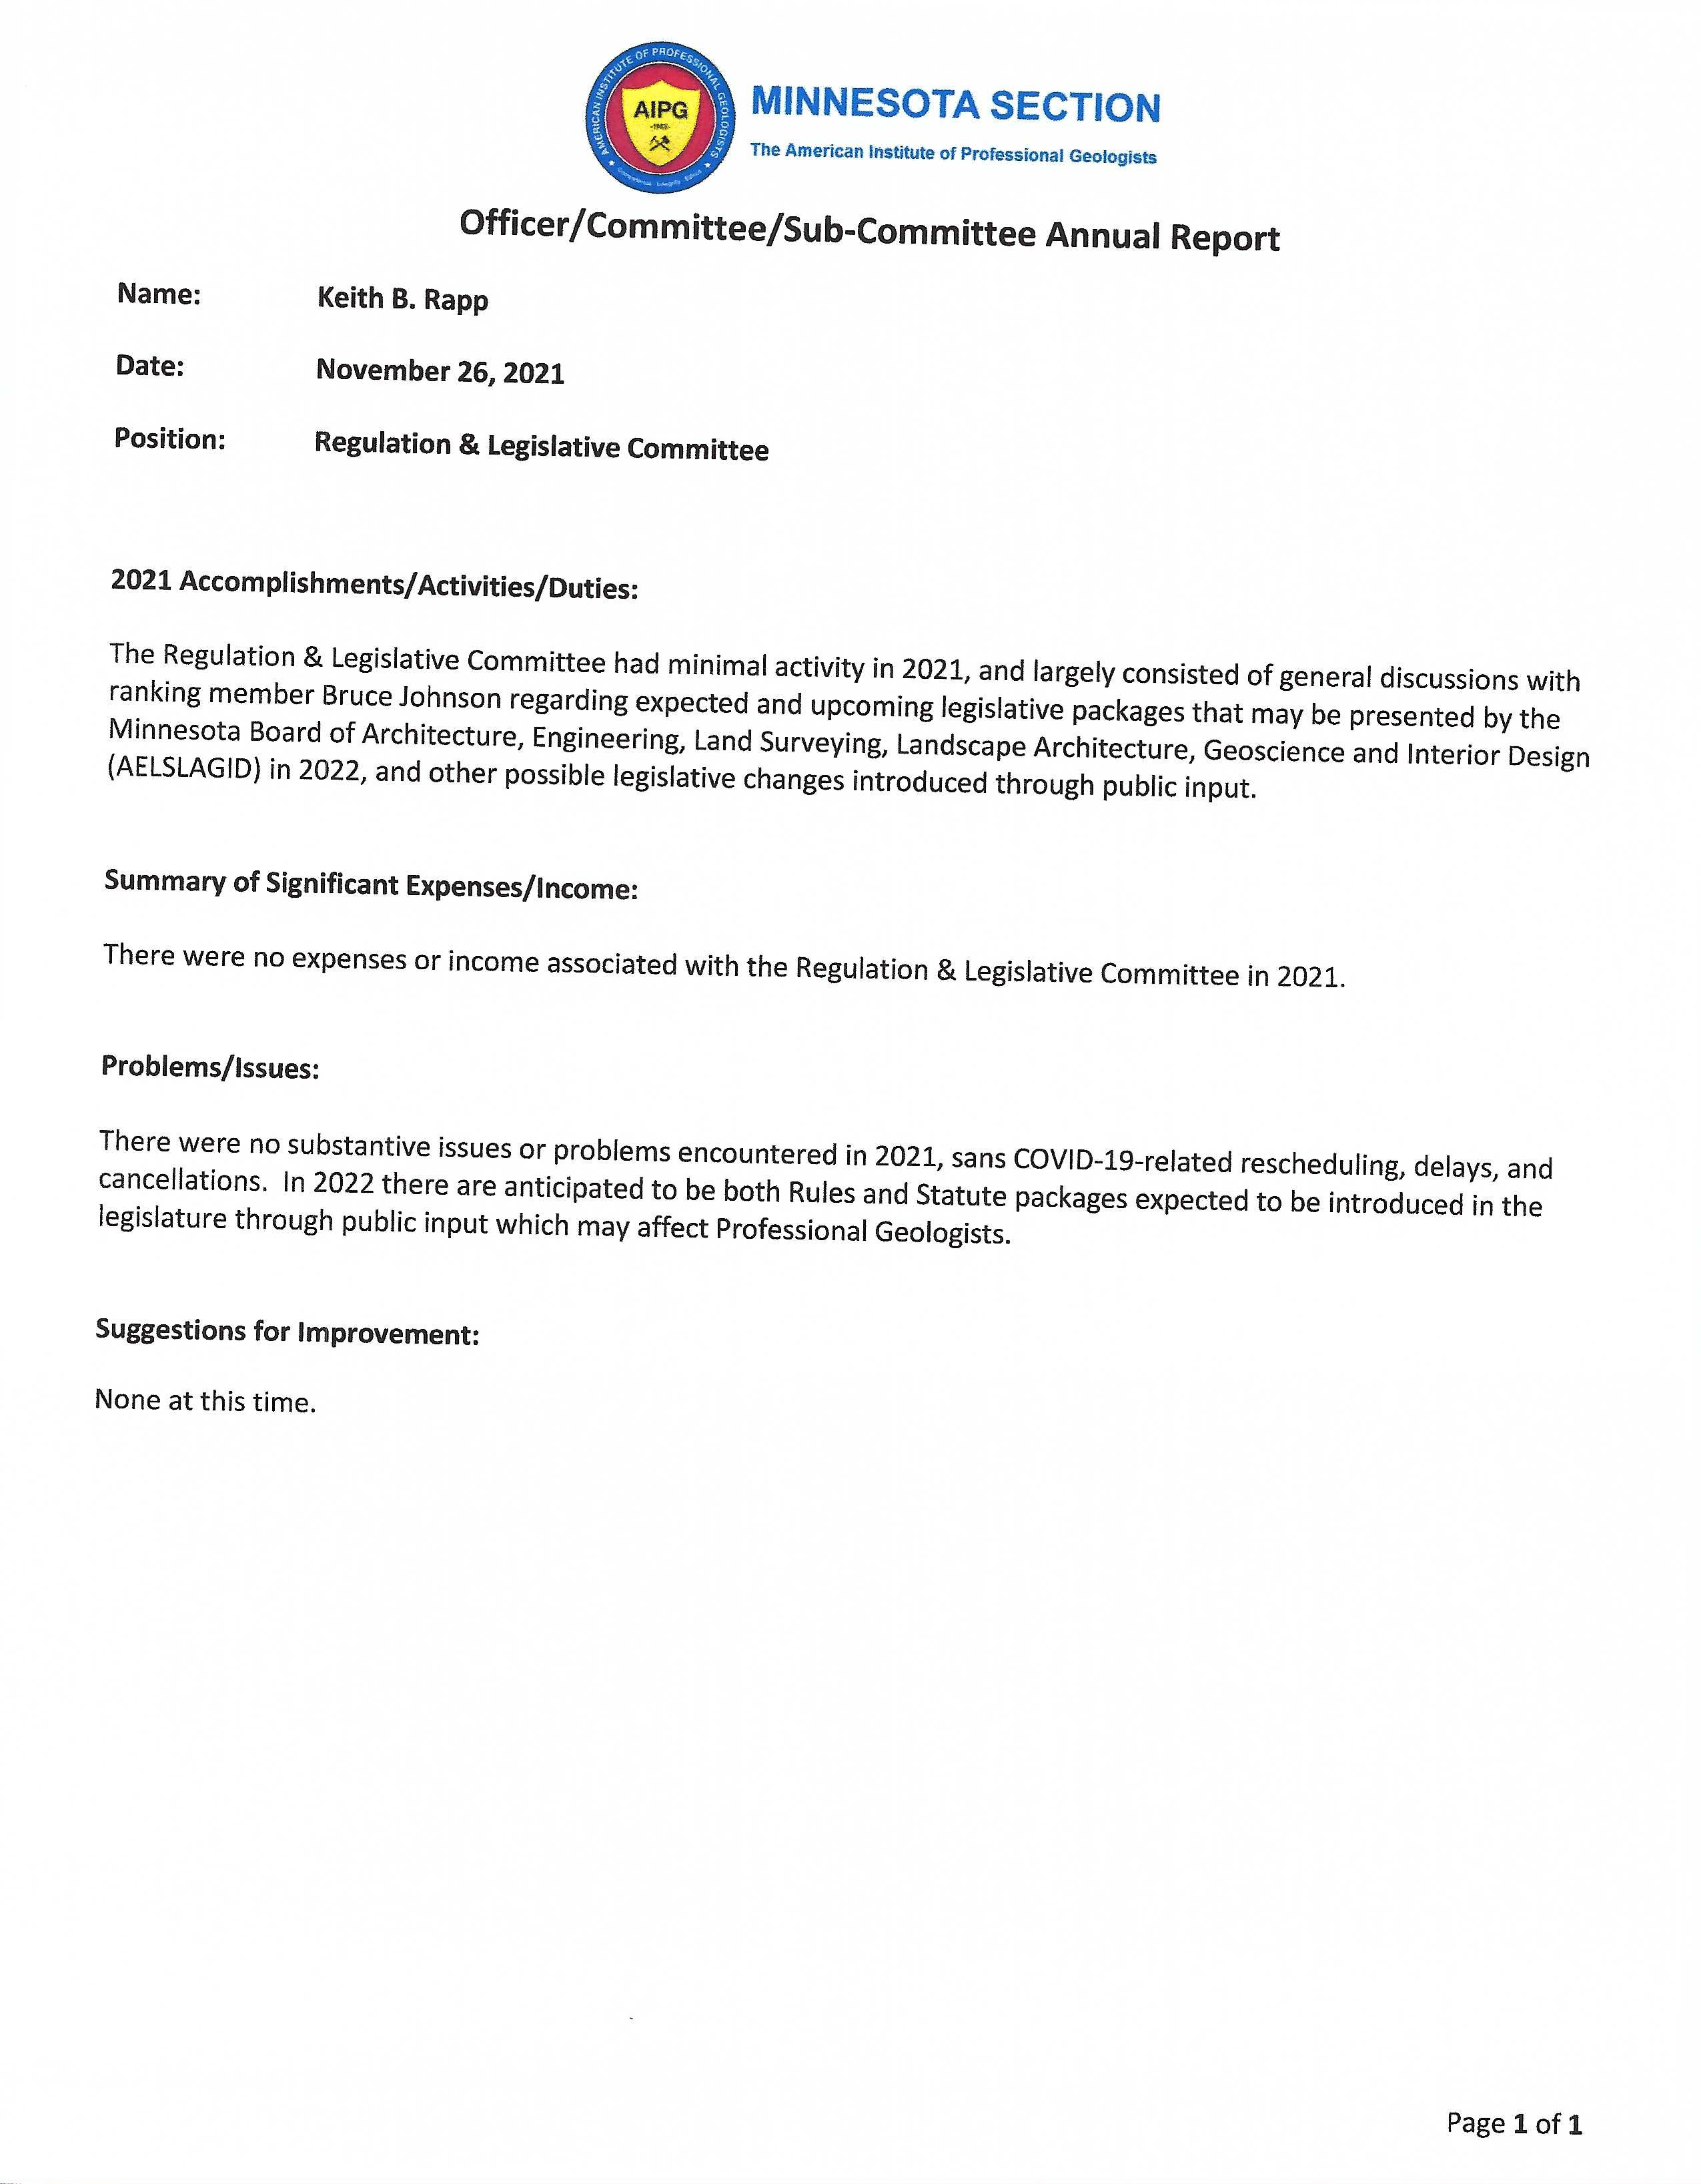

Officer/Committee/Sub-Committee Annual Report
Name: Shanna Schmitt & Jake Dalbec
Date: December 13, 2021 (Updated 12/15/2021)
Position: Webmaster
2021 Accomplishments/Activities/Duties:
- Approve job postings – 30
- Draft/send Announcements – 14
- Website updates o Normal updates
- Website Stats o 13 documents uploaded to website o 91 individual (non-scheduled) emails sent o 86 scheduled emails sent o 48 events added to website o 654 orders through the website
- We switched from PayPal to StarChapter Pay in mid-February 2021 o No reconciliation issues o Smooth experience for most users
    - We chose StarChapter Pay’s plan #2 with a $14.95 monthly fee, 2.80% transaction cost, and a $0.25 transaction fee.
    - 360 transactions through 12/13/2021
- Each technical talk is advertised on our LinkedIn group page, the AIPG National LinkedIn group page, and our Facebook page.

Summary of Significant Expenses/Income:
- We pay $100/month for StarChapter ($1,200/year)
- We started using StarChapter Pay in late February. We pay $4.95/month for the StarChapter Pay gateway ($49.50 this year). We also pay $0.25 per transaction and 2.80% per transaction, which was $348.64 (February through November), for an average of $38.73/month.
- We pay $16.50/month for our Microsoft 365 Business Standard package from PowerObjects ($198/year) o This includes the audio conferencing line that allows users to call-in with a phone if their connections are bad
- Student registrations are up

Year | Student Registrations | Value
2014 | 19 | $304.00 | (at $16/each)
2015 | 60 | $960.00 | (at $16/each)
2016 | 40 | $640.00 | (at $16/each)
2017 | 35 | $560.00 | (at $16/each)
2018 | 12 | $192.00 | (at $16/each)
2019 | 20 | $320.00 | (at $16/each)
2020 | 21 | $105.00 | (at $5/each)
2021 | 36 | $180.00 | (at $5/each)
Total | 243 | $3,261.00

- Attendance at our monthly technical talks is one of our biggest revenue streams, see the table on the following page.
o Member price is $5 o Non-member price is $10 o Student price is FREE (see above)

Attendance | Revenue | Date | Meeting Name
74 | $545 | 1/5/2021 | AIPG MN Jan Meeting - Non-Stick Future: PFAS Remediation and Regulation!
41 | $245 | 2/2/2021 | AIPG MN Feb Meeting - Life-Cycle / Circular Economy Concepts - Potential Applications to Minnesota's Mineral Resources!
57 | $330 | 3/2/2021 | AIPG MN Mar Meeting - Impacts of Glaciation on River Profile Morphology and Evolution!
72 | $460 | 4/6/2021 | AIPG MN & AWG MN Apr 2021 Meeting - Till: spatially variable, complex and dense!
43 | $250 | 5/11/2021 | AIPG MN May Meeting - Allianz Field Soccer Stadium: Addressing Subsurface Contamination by Innovative Design & Construction!
15 | $65 | 6/1/2021 | AIPG MN June Meeting - Experimental Investigation of Mantle Heterogeneity!
50 | $305 | 9/7/2021 | AIPG MN Sept Meeting - Bioremediation 3.0, awkwardly described by a geologist
47 | $330 | 10/5/2021 | AIPG MN Oct Meeting - Understanding Hydroclimatic Change in Minnesota
43 | $270 | 11/2/2021 | AIPG MN Nov Meeting - Minnesota Groundwater Provinces 2021!
50 | $320 | 12/7/2021 | AIPG MN Dec Meeting - CenterPoint Energy Waterville Gas Storage Project!
492 | $3,120
49.2 average attendance per meeting
$312 average revenue per meeting

Suggestions for Improvement:
- Find more volunteers
- Get out-state Minnesota engagement with our online platform
- Get more national registrants
- Offer a BIPOC grant

StarChapter also recommends several things to drive membership, engagement, and sponsorships (this is the same as last year): 1. Use videos
  - Semi-scripted/more natural
  - Sponsor stories
  - In the moment (when we can do it in person)
- Have tiered sponsorships (we can build forms for this) & create a Renewal Catalog for our returning sponsors, so they don’t have to enter the same info each year.
- Create conferences for non-dues revenue building
  - Early Career Professional (ECP) focus?
  - Topic focused?
- Create an annual summary report for members/sponsors
- Ask sponsors to provide content, like articles for newsletter or just on website.
  - They can write content in their area of expertise
- Show sponsorship value
  - Free meeting registrations
  - Classified job listings
  - Logo or QR code on name badges
  - Ad space on website
  - Mention in newsletter or meeting announcements
- Swag
  - Association labeled items
  - Sell raffle tickets
  - Sell books

Officer/Committee/Sub-Committee Annual Report
Name: Jake Dalbec
Date: December 13, 2021
Position: Assistant Webmaster, State Mapping Advisory Committee (AIPG Rep.)
2021 Accomplishments/Activities/Duties:
  - Actively participated in the MN Section of AIPG Executive Committee meetings and technical talks this past year.
  - Assisted with Webmaster duties as requested by Shanna Schmitt (Webmaster) and as necessary.
  - Represented the MN Section of AIPG in the annual State Mapping Advisory Committee (SMAC) meeting on October 28, 2021. Please see attached letter summarizing SMAC’s meeting and recommendations put forth by the group.

Summary of Significant Expenses/Income: None

Problems/Issues: Overall, 2021 was a good year for the MN Section of AIPG. There were only a few hiccups related to ExComm meeting administration through the Microsoft Teams platform; we are on track to acquire some backup licenses for additional ExComm members in 2022 pending a planned discussion on the topic at this 2021 Annual Meeting.

Recruiting volunteers to run for officer election and be active on the Executive Committee continues to be a struggle. Several initiatives including the BIPOC Committee lost momentum at times this past year.

Suggestions for Improvement:
  - Acquire additional Microsoft Teams licenses for our Section to administer online meetings, technical talks and discussions.
  - Continue to recruit geologists to be active in the MN Section of AIPG.
  - Assemble a functioning Nominating Committee and Screening Committee for 2022.
  - The ExComm leadership including the President should identify which initiatives/priorities will be the focus of the Section in 2022 so desired progress can be made on the selected initiatives.
1 1
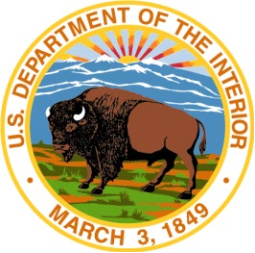
United States Department of the Interior
U.S. GEOLOGICAL SURVEY
Upper Midwest Water Science Center

Minnesota Office | Wisconsin Office | Michigan Office
2280 Woodale Drive | 8505 Research Way | 5840 Enterprise Drive
Mounds View, MN 55112 | Middleton, WI 53562 | Lansing, MI 48911
763.783.3100 | 608.828.9901 | 517.887.8903

November 8, 2021

STATEMAP Proposal Evaluation Panel

Dear Panel Members,

The Minnesota Geological Survey (MGS) State Mapping Advisory Committee (SMAC) convened on October 28, 2021 to review MGS mapping programs and the State Mapping Plan, and to consider mapping projects for the 2022 season as well as to review ideas for supplemental project funding as part of the U.S. GeoFramework Initiative.

All SMAC members were in attendance, save one. We also had two guests from private companies sit in on the virtual meeting in response to the panel feedback that we would benefit by including more representatives from the business sector. Names and affiliations of committee members and guests are included in a table on the last page of this letter.

The meeting began with a review by Barbara Lusardi, Associate Director of the MGS, of all MGS mapping programs and funding sources to evaluate efficiency, compatibility, and leveraging of resources with the STATEMAP Program. Each funding source, including STATEMAP, has its own unique guidelines and spending restrictions that are considered in the State Mapping Plan. MGS seeks to identify and employ the most appropriate funding source to address geologic mapping needs and to coordinate resources to increase the impact and value of each mapping effort.

The next agenda item was a review of STATEMAP goals, requirements, and limitations, and mapping progress in Minnesota. The committee discussed priority areas for future mapping based on the MGS mapping plan and the objectives of the National Geologic Mapping Act.

The SMAC reviewed the current State Mapping Plan (included in the MGS proposal) and found it reflected an appropriate balance of comments from the Panel, the directives of the State Legislature, and the implications of State efforts to sustainably manage groundwater and other geologic resources. The demand for statewide comprehensive geologic mapping and associated databases makes all unmapped areas a priority. The influence of local government participation, water, mineral, and hazard management issues, and scientific opportunity are important factors in the State Mapping Plan. We, and the plan, also favor those areas where there is a commitment to apply geologic mapping to a scientific or societal challenges.

The SMAC found these guiding principles and the State Mapping Plan to be effective and welldesigned for advancing geologic science and mapping programs, including STATEMAP in Minnesota.

The committee then reviewed the slate of projects proposed by MGS staff. Each proposal was reviewed with a focus on congruence with the State Mapping Plan, costs and value, scientific and societal value, as well as the skills, experience, and past mapping products of the geologists involved. The Minnesota Legislature supports geologic mapping, and this proposal reflects that commitment and an expectation that federal cost-sharing is appropriate to leverage the state’s investment.

The SMAC reviewed six county-scale mapping projects. The committee recognized that personnel availability and other funding opportunities may change in the eight months before these projects are initiated and has given MGS management full authority to choose how to respond to any reduced award. The projects we chose fit the mission and goals of the STATEMAP Program and of the Minnesota Geological Survey and its SMAC. The recommended projects are:

- Cook County, Northeast Minnesota
Bedrock Geologic Map of the northern portion (1:48,000 scale):
STATEMAP and the Environment and Natural Resource Trust Fund supported geologic mapping in Lake and St. Louis counties for the past six years. Interim products of this work are in high demand. Mapping in Cook County will complete our county-wide mapping along the North shore of Lake Superior. Because of the complex bedrock geology and the extent of outcrop in rugged terrain, only portions of the northern part (equivalent to about 4 quadrangles) of the county will be mapped this year (at a printed scale of 1:48,000). This map will allow us to refine regional interpretations by acquiring new outcrop and drill-hole data, fully attributing tens of thousands of outcrop polygons, conducting petrographic analyses to improve map unit definitions, and adding new and archived structural data. The proximity of existing and proposed new mining operations to wilderness areas requires a thorough understanding of the bedrock as part of ground and surface water systems. This work is essential in order to characterize the geology and evaluate potential environmental issues.

- Surficial Geologic Map of Lyon County, Southwestern Minnesota (1:100,000): The purpose of this project is to provide a detailed geologic map that can be used by planners and resource managers as a decision-making tool when assessing the location, protection, and prudent use of geologic resources; including groundwater and aggregate materials. New data gathered for this project will improve the understanding of the geological connection between surface water and groundwater resources in the counties. Surficial mapping will also be utilized by the Minnesota Departments of Health and

Natural Resources as an essential component of assessing groundwater sensitivity to contamination.

- Bedrock and Surficial Geologic Maps of Lake of the Woods County, Northern Minnesota (1:100,000):
This project will provide detailed geologic maps that will inform planning and resource management decisions with regards to the protection and utilization of resources; including groundwater, crushed rock and glacial aggregate materials, and potential metallic resources. The maps will be an important element of comprehensive geologic mapping and associated databases assembled as a County Geologic Atlas.

- Bedrock and Surficial Geologic Maps of Waseca County, Southern Minnesota (1:100,000):
This project will provide detailed geologic maps that will inform planning and resource management decisions with regards to the protection and utilization of resources; including groundwater extraction for irrigation and drinking water, crushed rock and glacial aggregate materials, and potential metallic resources. The maps will be an important element of comprehensive geologic mapping and associated databases assembled as a County Geologic Atlas.

- Surficial Geologic Map of Faribault County (southern half), Southern Minnesota (1:100,000):
This project is a continuation of current work and will complete the surficial mapping of the county. This map can be used by planners and resource managers as a decisionmaking tool when assessing the location, protection, and prudent use of geologic resources; including groundwater and aggregate materials. New data gathered for this project will improve the understanding of the geological connection between surface water and groundwater resources in the counties. Surficial mapping will also be utilized by the Minnesota Departments of Health and Natural Resources as an essential component of assessing groundwater sensitivity to contamination.

- Aggregate Map of St. Louis County (southern half), Northeastern Minnesota (1:50,000 assessment/print scale will be determined by plate size):
This project will be conducted by the Minnesota Department of Natural Resources (DNR), who is authorized by Minnesota Statute to identify and classify aggregate resources outside of the Twin Cities metropolitan area. Data from this project is essential for locating and protecting economically viable resources that are essential to the state’s infrastructure. This derivative map will be based on geologic mapping of St. Louis
County conducted by the MGS and funded, in part by the USGS STATEMAP program.

Costs for projects 1 through 5 will be matched by State grants to the MGS from the Environment and Natural Resource Trust Fund (ENRTF). These projects will support water and mineral resource management, local management of water and infrastructure, source water protection, and are well aligned with ongoing scientific research projects being conducted at public and private universities and colleges, federal and state regulatory agencies, and regional planning organizations. While this is new mapping that is being proposed as New Mapping under Category 1, Criteria 1, it also fits into the U.S. GeoFramework Initiative (Category 2, Criteria 3) for new mapping required for framework syntheses. Maps created as part of the MGS County Geologic Atlas program are also integrated into statewide databases.

Project 6 will be matched by State grants to the Minnesota DNR also from the ENRTF. This project will support mineral resource management as well as long-term land-use planning.

Collectively, these projects cover a diverse set of geologic conditions throughout Minnesota; balancing a variety of scientific issues and constituency needs that are strongly supported by geologic mapping. This proposal supports the MGS mission and goals, the DNR mission and goals, the goals of STATEMAP, and the guiding factors of the Minnesota State Mapping Plan.

The SMAC appreciates the opportunity to propose mapping areas and to review staff proposals for the STATEMAP program. We value the mapping produced by MGS and the thoughtful process by which projects are prioritized.

Sincerely,

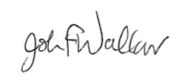
John Walker, SMAC Chair

Presenters:
Barbara Lusardi, Associate Director of the MGS
Tony Runkel, Lead Geologist at the MGS

Guests in Attendance:
John Cunningham, Executive Director of the MN Aggregate and Ready Mix Association
Evan Christiansen, Senior Hydrogeologist, Barr Engineering
Name | Affiliation | Expertise | Attended? | Voting Member
Ole Olmanson | Shakopee Mdewakanton Sioux Community | geology, natural resource management | Yes | Yes
John Clark | Minnesota Ground  Water Association,  Metropolitan Council | geology,  biogeochemistry, and water supply planning | Yes | Yes
Paul Putzier | DNR Waters Division | geology, groundwater resources, policy | Yes | Yes
Joshua Feinberg | Department of Earth and  Environmental Sciences,  University of Minnesota | mineralogy, geophysics, field and environmental  geology | Yes | Yes
Jane de Lambert | MN Department of  Health, Environmental  Health Division | groundwater and water wells | Yes | Yes
Louis Rudnicki | Society for Mining,  Metallurgy, and  Exploration | aggregate mining and engineering | No | Yes
Jake Dalbec | American Institute of Professional Geologists | geology and environmental consulting | Yes | Yes
John Walker | USGS Upper Midwest Water Science Center | hydrology, geochemistry, modeling | Yes | Yes

Officer/Committee/Sub-Committee Annual Report
Name: Miller Gruenewald
Date: December 15, 2021
Position: Secretary
2021 Accomplishments/Activities/Duties: My duties for 2021 were to take the meeting minute notes for Executive Committee meetings. Once the minutes were approved at the next month’s meeting, I was to upload the minutes to the AIPG website.

Problems/Issues: Due to the nature of my current position within my company I was working in the field during most of this year’s Executive Committee meetings. I was not able to record the minutes or upload approved minutes to the AIPG webpage. I feel the organization is running well through the pandemic. AIPG MN has been able to adapt with virtual talks and meetings.

Suggestions for Improvement: AIPG MN should revisit in-person student happy hours.

