AIPG MN – ExCom Meeting Minutes
July 25th, 2023 (2 PM to 3 PM Central)
Microsoft Teams

Meeting Prep: Review Agenda
Meeting Purpose: AIPG Minnesota ExCom Meeting to discuss future activities, talks and progress with the board and bring up any requests from the board or members
President |  | President Elect |  | Vice President |  | Secretary |  |  |  | Treasurer
x | Ben Czeck | x | Marian Kramer | x | Jason Gelling | x | Rob Blakely |  |  | x | Rebecca Ryser
Executive Committee |  |  |  | Fundraising Chair |  | Membership Chair |  |  |  | Education Chair
x | Alex Blel | x | Patrick Sweeney |  | Curt Hudak |  | Paula Berger |  |  |  | Jake Dalbec
 | John Berger |  | Sophia Link | Reg & Leg Chair/AELSLAGID |  |  |  | Screening Chair
x | Micaela Anderson |  | Eric Lonetti |  | Dan Hunter |  |  | x | Dan Hunter
Nominating Chair |  | DE&I Chair |  | Webmasters
 | Unappointed | x | Dan Hunter |  | Shanna Schmitt |  | Jake Dalbec
Do we meet the requirements to have a quorum for this meeting?
x | Yes |  | No

Agenda:
- Call to Order

- Roll Call

  - Need to update National regarding Dan filling the Screening Chair position
    - Dan Hunter is the new Reg & Leg Chair/AELSLAGID

- Approve past meeting minutes

  - April
  - May (still need the meeting minutes uploaded)

- Technical Talks – Fall Speakers
  - Per Jason, will follow up w/ Peter Kang, Jared Trost, and Tony Runkel for speaking opportunities this fall
  - Exact dates are flexible. Usually first or second Tuesday of the month at noon. Logon @ 11:45 to make sure they’re setup.
  - Looking at Sept 12th to kick things off.

- AIPG Annual Account Summary Tracking Spreadsheet
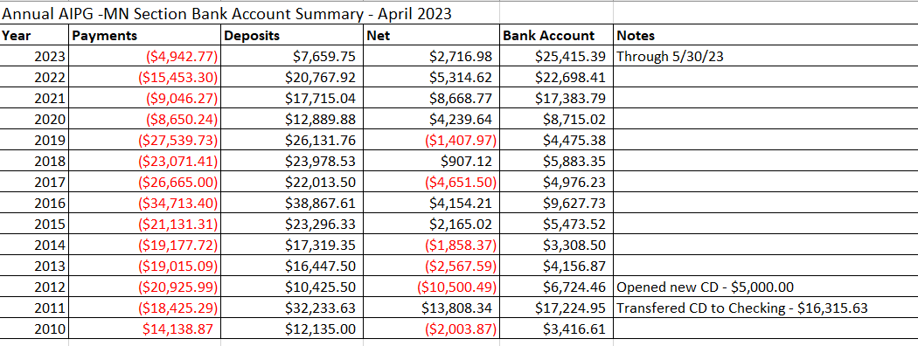
- UPDATE - 2023 Golf Fundraiser – Stillwater Country Club – Monday June 12th
  - We netted $5,681 from the tournament. Overall we did really well.
  - 59 golfers; 15 non-golfers
  - Maybe look at charging credit card fees for those whom pay by CC. Might look into using Venmo or Zelle, although we just closed the PayPal account to save on fees.
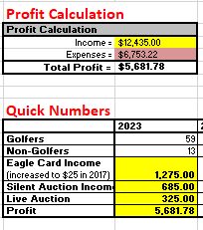

- Committee Chair Updates
    - Screening Committee – Dan Hunter
    - Nominating Committee – Unappointed in place by August
    - Regulation and Legislative/ASBOG Committee – Keith Rapp
    - Membership Committee – Paula Berger (looking for coverage)
      - Sponsorships through the end of the year and early 2023
    - Fundraising Committee – Curtis Hudak
    - Education Committee – Jake Dalbec
    - DE&I Committee – Dan Hunter
      - DEI Moments Tracker.docx
      - Next meeting in September
      - How are your companies/organizations addressing DEI issues or educating employees?
      - Dan is giving the DEI moment for September Technical Talk and Michael will be doing the October Talk.

- Any Additional Business for Discussion?
  - Marian got an email re: the national conference – that a portion of it will be virtual.
    - Workshops, ExComm meetings, student meetings, etc
    - Virtual field trip available to those attending the conference

- Adjournment
  - Meeting adjourned at 2:29pm

